***Module – 03***

**What is LCA (Life Cycle Assessment)**

An LCA is a systematic analysis of environmental impact over the course of the entire life cycle of a product, material, process, or other measurable activity. LCA models the environmental implications of the many interacting systems that make up industrial production. It is also a process of evaluating the impact of a product on the environment over its entire period, hence helping in increasing its resource-use efficiency and decreasing the liabilities.

**What is a Life Cycle?**

Consecutive and interlinked stages of a product or service system, from the extraction of natural resources to the final disposal.

**Stages in a life cycle of a product/material/ service**

1. **Raw material extraction:** any product or service to be produced, needs raw materials. The life cycle starts with the sourcing of such raw materials, i.e extraction or production of the raw materials which is required for the manufacturing of the product. This process may also include the transportation of the raw materials from the place of extraction to the place of manufacturing of the product.
2. **Manufacturing and processing**: This step or process involves the industrial process of the raw materials to produce a meaningful product o service through technology or any means of process available.
3. **Transportation/ Logistics:** this step involves the transportation of the produced raw materials to place of consumption or the market for retail distribution to the consumers.
4. **Use of the product:** In this step, the product is consumed at the place of distribution.
5. **Disposal:** Once the utility of the product is completed, it is disposed or discarded as waste material. This waste may either end up in the waste-disposal yard or maybe used as a raw material input/ source for the manufacture of a new product.

**What is LCA Models or Approaches**

1. **Cradle to Grave Approach:** This type of approach is preferred or used when the product is analysed for its impacts and effects to the environment**,** from the time of its origin i.e., the place of its raw materials extraction to the end of the use of the product. This approach will end when the useful life of the product is over. The cradle to grave approach will not consider the impact if the product once used/ completion of the useful life is used as a raw material for a new product.

**Example:** Non-Biodegradable plastics, Wood, Paints, Textiles

1. **Cradle to Grave Approach:** This type of approach is used when the product from its raw material extraction stage is analysed up to its useful life stage and is also viewed as a potential raw material for a new product or can be used a source of raw materials for the same product.

**Example:** E-waste, Glass Bottles, Steel,

1. **Cradle to Gate Approach:** This type of approach is used when the product’s impact is analysed till the product leaves the factory gates, i.e., the impact of transportation or consumer use or waste disposal is not considered.

**Example:** All products which are manufactured in the industry – up to its exit from the manufacturing set-up

**Process of LCA**

1. **Goal & Scope Definition**: In this phase, the product or service that is being assessed is defined under the set boundary conditions. The LCA also requires a functional unit (Ex. No. of PET Bottles, Total Distance of Travel, etc.) to be defined for the analysis. This step defines the goals and objectives of the process of LCA. The decision on what is to be analysed and the process for it is identified.
2. **Inventory Analysis**: Here you perform a data compilation and an inventory analysis of extractions from and releases into the environment. The final inventory provides a list of all inputs and outputs associated with the [life cycle of your product or service](http://sphera.com/product-sustainability-software/). In the inventory analysis, the inputs and outputs of the process is identified. The inputs (i.e., raw materials) for the manufacturing of a product and the output (i.e., emissions, hazard, product) is very essential for carrying out the LCA.
3. **Impact Assessment:** In impact assessment, the classification of resource use and emissions generated according to their potential impacts is quantified for assessment of the impact through the goals set by the LCA
4. **Interpretation:** the final discussion of the results in terms of contributions, relevance, robustness, data quality and limitations, opportunities for reducing the negative effects of the product(s) or service(s) on the environment while avoiding burden shifting between impact categories or life cycle phases. Avoiding burden shifting is a core strength of the LCA approach.

**Impact Categories for Step 03 (Impact Assessment) in LCA**

1. **Climate change (a.k.a., global warming or carbon footprint)—**A measure of greenhouse gas emissions, such as CO2 and methane. These emissions are causing an increase in the Earth’s absorption of radiation emitted by the sun, increasing the greenhouse effect. This can in turn have adverse impacts on ecosystem health, human health and material welfare.
2. **Eutrophication (a.k.a., overfertilization)—**Eutrophication covers all potential impacts of excessively high levels of macronutrients, the most important of which include nitrogen (N) and phosphorus (P). Nutrient enrichment can cause an undesirable shift in species composition and elevated biomass production in both aquatic and terrestrial ecosystems (e.g., potentially toxic algal blooms). In aquatic ecosystems, increased biomass production may lead to depressed oxygen levels because of the additional consumption of oxygen in biomass decomposition.
3. **Acidification—**A measure of emissions that cause acidifying effects to the environment. The acidification potential is a measure of a molecule’s capacity to increase the hydrogen ion (H+) concentration in the presence of water, thus decreasing the pH value (e.g., acid rain). Potential effects include fish mortality, forest decline and the deterioration of building materials.
4. **Smog formation (a.k.a., photochemical ozone creation)—**A measure of emissions of precursors that contribute to ground level smog formation (mainly ozone O3), produced by the reaction of VOC and carbon monoxide in the presence of nitrogen oxides under the influence of UV light. Ground level ozone can be detrimental to human health and ecosystems and may also damage crops.
5. **Particulate matter (a.k.a., dust and aerosol emissions)—**A measure of particulate matter emissions and precursors to secondary particulates, such as SO2 and NOx from sources like fossil fuel combustion, wood combustion and dust particles from roads and fields. Particulate matter causes negative human health effects, including respiratory illness and an increase in overall mortality rates.
6. **Ozone depletion—**A measure of air emissions that contribute to the depletion of the stratospheric ozone layer (i.e., the ozone hole). Depletion of the ozone leads to higher levels of UVB ultraviolet rays reaching the Earth’s surface with detrimental effects on humans and plants.

**Necessity of LCA**

1. **Process and product-design improvement:** LCA helps manufacturer streamline and improve their products process, ensuring efficient use of resource and improve the design and life cycle of the product to enhance the useful life of the product and its performance.
2. **Marketing (e.g., backing up environmental claims or meeting consumer demand for green products):** Good practices shall improve the brand image of the product, enabling LCA techniques in the organization will allow for sustainable development of the industry.
3. **Hot-spot analysis to facilitate continuous improvement:** LCA shall analyse and identify potential hazard areas and hot-spots to improve on the logistical pathways and process of the industry.
4. **Third-party verification or certification:** LCA plays a pivotal role while issuing certificates and registrations to organizations and industries.
5. **Method for quantifying key environmental impacts (e.g., greenhouse gas, carbon emissions, water use, and energy consumption):** LCA enables the organization to understand the number of emissions produced by it during its process of manufacturing or life cycle, in terms of quantifiable data.
6. **Goal setting for climate-change and other sustainability policies:** Enables organizations to understand the social impacts of the products and in turn help policy makers to arrive at organizational policies and regulations towards sustainable development.

**Advantages of LCA**

1. LCA considers the full life cycle and it avoids burden shifting i.e., it prevents reducing the environmental impact in one stage while increasing the impact at other stages of the life cycle. Rather than optimizing one indicator.
2. LCA provides a holistic view on the environmental impacts, to avoid optimizing one environmental indicator without considering the (unfavourable) effects on the other indicators.
3. LCA provides the possibility to identify hotspots in the environmental impact.
4. LCA provides insight in how to improve processes to achieve reduced environmental effects.
5. LCA is based on internationally accepted standards and is widely recognized as the best approach to quantify the environmental impacts of a product on the environment during its entire life cycle.
6. LCA provides insights to companies and organizations for better policy making and legislations for moving towards sustainable development.

**Disadvantages of LCA**

1. LCA studies depend on assumptions and scenarios, as LCA assesses the real world in a simplified model.
2. LCA studies also have different scopes, so one study may leave out impacts or processes that another study has included.
3. The assumptions, scenarios and scope may vary from one study to the other, leading to different LCA results. These variations in LCA approaches and results may be confusing, especially for non-experts.
4. Performing an LCA study is resource consuming, mainly due to the large amount of data needed. If data collection is poor, or if not, enough data are available, the study will not lead to solid conclusions.

**List of LCA Software’s**

1. **Ecochain Mobius:** Ecochain Mobius is one of the **easiest-to-use** Product Footprint and LCA tools available. With its intuitive interface and extensive in-tool guidance, users learn to measure and improve the environmental footprint of their product(s) in a short amount of time. Access to the world’s biggest environmental impact databases is included at no extra cost. The databases include the use of EcoInvent, the Environmental Footprint (EF), and the Dutch Nationale Milieudatabase (NMD). Combined they cover a lot of detailed environmental information on most materials, ingredients, or components.

1. **Ecochain Helix:** Ecochain Helix helps **manufacturing companies** measure & improve the environmental footprint of complete product portfolios and large-scale production facilities. Helix’s focus is creating LCAs in bulk and uses a top-down approach, called Activity-based Footprinting. Helix provides high-level steering information for your company and provides dashboards of your environmental performance on a company, process, and product level. Next to that, you can create Product Footprints, LCA reports, and Environmental Profiles (LCA results) for your entire product portfolio – at once
2. **GaBi:** GaBi was created in the mid-’90s. It’s a very established LCA tool used in many industries, however, especially in its home market Germany. Just like SimaPro, GaBi is a technical extensive solution with many potential add-ons for sustainable product development. GaBi is used a lot by LCA experts and sustainability consultants. GaBi uses its own **specific LCI database** and allows you to make LCAs in different standards. In addition to making LCAs, the GaBi tool supports Life Cycle Costing and Life Cycle Reporting.
3. **OpenLCA:** OpenLCA has several deep-dive functionalities, which makes it useful for users with a more technical background. The software features enable you to adjust LCI datasets. This means the environmental datasets can be tweaked to match your product’s production process and inputs. Next to that, it also has several analytic features to assess the environmental impact and performance of your product. With OpenLCA you can more extensively investigate the environmental datasets you add to the application. This allows for advanced supply chain analysis. As mentioned earlier, LCA tools rely on LCI databases if you want to use them to measure impact. OpenLCA provides access to many different databases, and a large share of these databases is not free.
4. **SimaPro:** SimaPro was established 30 years ago and is probably the most well-known LCA software in the market. The tool is available as desktop software as well as a cloud-based solution. However, the cloud-based option does not contain all features. SimaPro is a technical application with many optional add-ons that make it very versatile. Additionally, it enables its users to dive deep into the [LCA calculations](https://ecochain.com/knowledge/life-cycle-assessment-lca-guide/) of a product and production processes.

**What is a database in LCA?**

The database contains international industrial life cycle inventory data on energy supply, resource extraction, material supply, chemicals, metals, agriculture, waste management services, and transport services with more than 18000 reliable datasets. The database is very transparent and consistent. Each data set is provided as unit process and aggregated system process. Moreover, since version 3 of the database, processes are provided for three different system models: "allocation at the point of substitution" (APOS), "allocation, cut-off by classification" (Cutoff) and "substitution, consequential long-term" (Consequential). Furthermore, reports with background information about modelling procedures and assumptions are published.

There are different database collection for different industry depending on the software being run. Most of the these databases are free to use and are readily available in the online.

**Examples of some databases:** Eco invent, Carbon minds, Impact world +, Environmental footprints, etc.

**LCA as an iterative process**

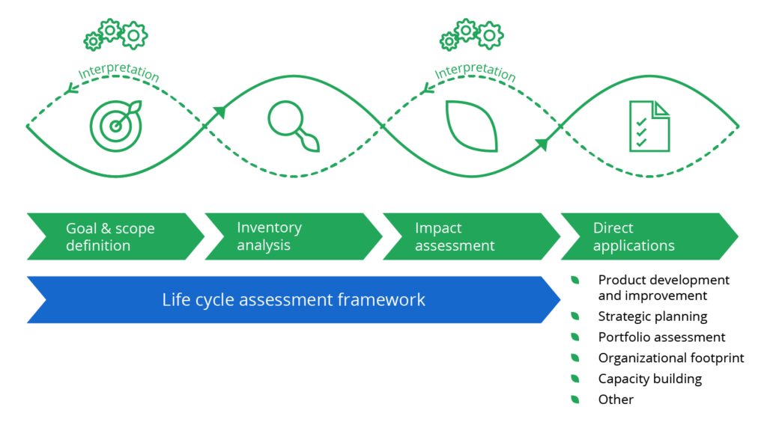

1. LCA is an iterative process as we keep changing views in the timeline during the analysis.
2. The LCA uses various data sets which is subject to changes over a period of time.
3. The goals and scoping of products will change within the given boundary set, hence the goals and scoping of LCA changes leading to re-processing and re-assessment.
4. Once the set targets are achieved through LCA, the organizations can improve their scope and revise their targets based on their achievements, which again calls for use of LCA.